**Hospital**

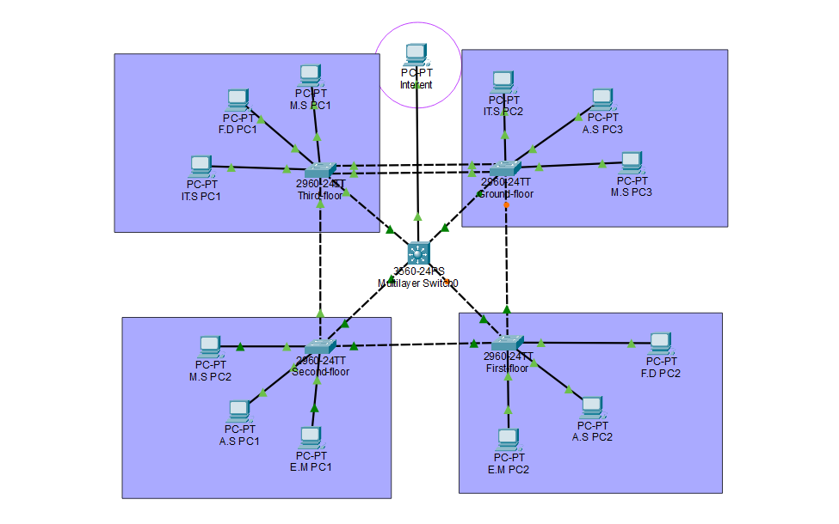

**Alise Aleksane**

**C00296656**

# **Introduction**

In this topology I will demonstrate how the hospital network communicates using inter Vlan routing this is done by using one layer 3 switch instead of router on a stick method. I decide on the layer 3 switch as it can communicated all Vlans simultaneously and I found it easier to set up. Each floor of the hospital has a layer 2 switch and 3 end devices for each Vlan to be assign to. I decide to do this with four switches as it would be evenly spread out to allow redundancy.

# **Departmental Segmentation Using VLANs**

Vlan 1 -Default

* This Vlan is assigned to all switch ports by default as it is hardcoded automatically to all the ports. It mainly used to manage traffic

Vlan 5 – Medic staff

Vlan 10 – Admin Staff

Vlan 15- IT-service

Vlan 20-Executive management

Vlan 25- Finance Department

Vlan 30- Unused

* I created this vlan for the hospital as it would create a security that a stranger can’t just plug in a cable and connect to the network as the unused ports would be placed in the vlan and shutdown. This also allows the hospital to have a secure network setup by doing this.

Vlan 99- Native

* I created this vlan to allow EtherChannel port to be assign to two switches to allow better network connection.

Vlan 100 -Management

* I created this vlan and assign different ip address to each switch and mls so I could allow ssh to work throughout the network so the staff can remote login.

Each of these vlan are configured on the switch and are assigned to the end devices even if they are not assigned, they are being configured. This is also done on the MLS switch as they are all configured.

|  |  |  |  |  |  |
| --- | --- | --- | --- | --- | --- |
| Switch | PC Name | Port | Assign Vlan | Pc IP Address | Port Mode |
| Ground-Floor | Medic-Staff 3 | Fa 0/6 | Vlan 5 | 192.168.5. 13/24 | Access |
|  | Admin-Staff 3 | Fa 0/5 | Vlan 10 | 192.168.10.13/24 | Access |
|  | IT-service 2 | Fa 0/4 | Vlan 15 | 192.168.15.12/24 | Access |
|  | GF To FF | Fa 0/3 | ---------- | ------------------ | Trunk |
|  | GF To TF | Fa 0/8  Fa 0/2 | ---------- | ------------------ | Trunk |
|  | GF To MLS | Fa 0/1 | ---------- | ------------------ | Trunk |
|  | Management | --------- | Vlan 100 | 192.168.100.4/24 | ------------ |
|  |  |  |  |  |  |
| First-Floor | Exec management 2 | Fa 0/4 | Vlan 20 | 192.168.20.11/24 | Access |
|  | Finance Dept 2 | Fa 0/6 | Vlan 25 | 192.168.25.12/24 | Access |
|  | Admin-staff 2 | Fa 0/5 | Vlan 10 | 192.168.10.11/24 | Access |
|  | FF To GF | Fa 0/2 | ---------- | ------------------ | Trunk |
|  | FF To MLS | Fa 0/1 | ---------- | ------------------ | Trunk |
|  | FF To SF | Fa 0/3 | ---------- | ------------------ | Trunk |
|  | Management | --------- | Vlan 100 | 192.168.100.2/24 | ------------ |
|  |  |  |  |  |  |
| Second-Floor | Admin-staff | Fa 0/4 | Vlan 10 | 192.168.10.12/24 | Access |
|  | Exec Management | Fa 0/5 | Vlan 20 | 192.168.20.12/24 | Access |
|  | Medic-Staff | Fa 0/6 | Vlan 5 | 192.168.5.12/24 | Access |
|  | SF To FF | Fa 0/3 | ---------- | ------------------ | Trunk |
|  | SF To TF | Fa 0/2 | ---------- | ------------------ | Trunk |
|  | SF To MLS | Fa 0/1 | ---------- | ------------------ | Trunk |
|  | Management | --------- | Vlan 100 | 192.168.100.10/24 | ------------ |
|  |  |  |  |  |  |
| Third-Floor | IT-service 1 | Fa 0/4 | Vlan 15 | 192.168.15.11/24 | Access |
|  | Medic-Staff | Fa 0/6 | Vlan 5 | 192.168.5.11/24 | Access |
|  | Finance-Department | Fa 0/ 5 | Vlan 25 | 192.168.25.11/24 | Access |
|  | TF To SF | Fa 0/2 | ---------- | ------------------ | Trunk |
|  | TF To GF | Fa 0/3  Fa 0/7 | ---------- | ------------------ | Trunk |
|  | TF To MLS | Fa 0/1 | ---------- | ------------------ | Trunk |
|  | Management | --------- | Vlan 100 | 192.168.100.3/24 | ------------ |
|  |  |  |  |  |  |
| MLS | MLS To Internet | Fa 0/5 | ---------- | ------------------ | ----------- |
| MLS | MLS To GF | Fa 0/4 | ---------- | ------------------ | Trunk |
| MLS | MLS To FF | Fa 0/3 | ---------- | ------------------ | Trunk |
| MLS | MLS To SF | Fa 0/2 | ---------- | ------------------ | Trunk |
| MLS | MLS To TF | Fa 0/1 | ---------- | ------------------ | Trunk |
| MLS | Management | --------- | Vlan 100 | 192.168.100.1/24 | ------------ |
|  |  |  |  |  |  |
| Internet | PC To MLS | Fa 0 | ----------- | 192.168.3.1 | --------- |

# **Inter-VLAN Communication and External Connectivity**

The connections to the switch and to the MLS are trunk mode as it would be able to carry multiple Vlan and allow a better efficiently inter-vlan routing .I decide on the layer 3 switch as it can communicated all Vlans simultaneously and I found it easier to set up rather then the router which would be an alternative method if the MLS ever failed . I used access mode for switch to pc as it assigned the port connected to the pc from the switch so only one Vlan will be assigned. This allows each end device to be connected to a different department through Vlans.

I made an external connection from the MLS to the remote pc(internet).i did because most often you need to used the internet. So I create this secure and safely to use outside the internal network.

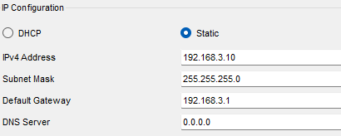I did this by going into the port on the MLS that connects to the pc and doing the command No switchport. This allows the port to become a route port. Which made it an external port then I assign it an ip address and used that ip as the default gateway for the pc.

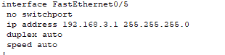

The IP from MLS being used as the the default gateway on the external pc

This is MLS CONFIGURES

# **IPv4 Addressing with Dynamic Allocation**

I used dhcp to assign an address to the pc dynamically. I done this so I wouldn’t have to manual assign each pc and it would be easier. And if there would be more pc added in the future that they could be dynamically assign as well. I Did this by using the MLS.

1. I made pools and name them for each department vlan

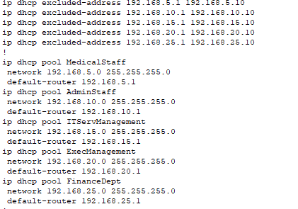I did this as it would be easier to identify which pool is which

1. Then assign a network ip address
2. The default router
3. I also excluded ip address

I

# **Network Redundancy for High Availability**

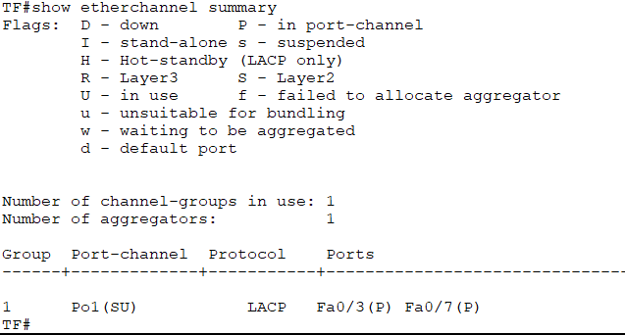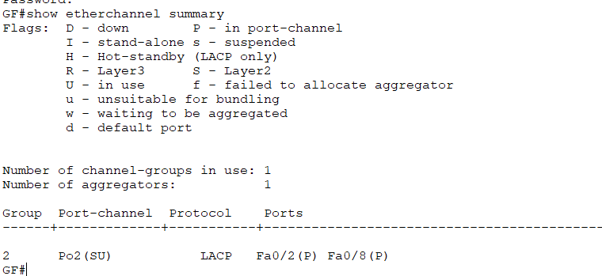I decide to make an ether channel between the third floor and ground floor as it would provide an extra layer of redundancy as well as enhance performance. I did this by making two channel groups and assign them to the correct port on each switch. While also making it a trunk line with native 99.

And conclusion

# **Network Device Security and Hardening**

# **SSH**

I decide to use SSH so the administrator could login in remote and this would be an advance because the data would be secured.

I did this by having a management vlan and having a different ip address on each switch and MLS. The MLS ip address would act as the default gateway for the rest of the switches. On each switch and I made the domain name the name on the floor so It would be specific and easier to find. The crypto key I put as 1024 as it would encrypt the data that is sent.i set the user name as admin as the admin would be login in and managing it all. I config it to the line vty 0 15 this would allow 16 remote users to access. Login local also the user and password. Transport input ssh allows this process to go through.

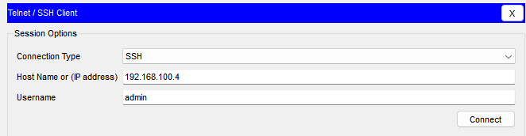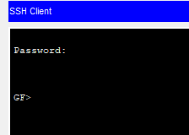

**Password**

I added password so it would be more secure and also encrypted them as it would be harder to access the password. The line console password is cisco and the secret password for enable is class. For all the switches and including the MLS. This would prevent unauthorized users from access the system.



# **Banner**

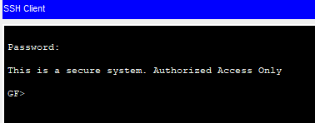I also added a banner. This aware the user it a secure system. i added this to give the user information notices. This is also shows up when you login into ssh aware the user.

